- KAPISH GOYAL XI A

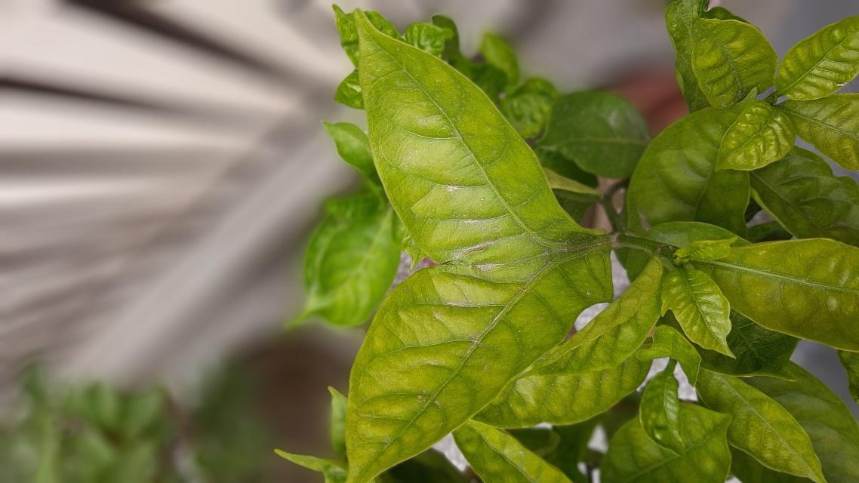

The Photograph presented above is a leaf of a plant potted in my house. In this photo, I have presented you a CONJOINED leaf. Everyone is aware of what a conjoined means, we may have photos of conjoined babies but a leaf?!!!! never there is a very extremely very rare case of conjoined baby and of a leaf, it is epicly rare. I have never seen anything like this in my life and assume that you haven't either...

- NIKHIL JOHARI IX C

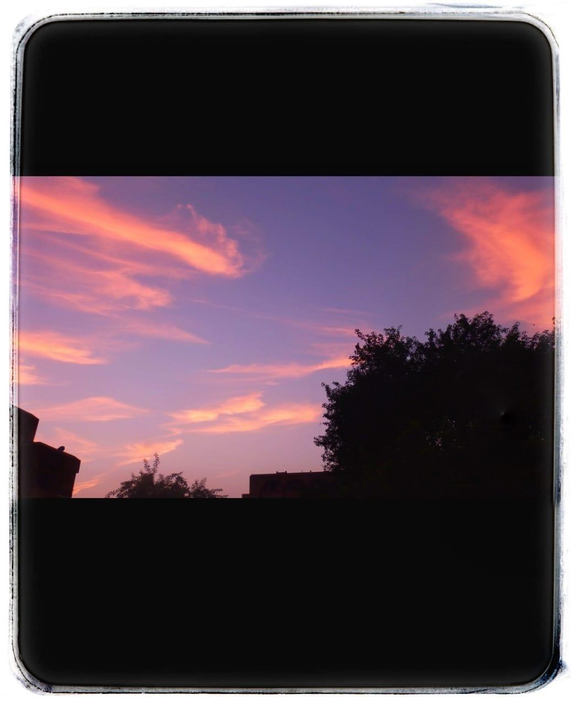

The sky had an explosion of colours. The clouds were painted by the strokes of beauty. This was a magnificent scene I was able to capture through my camera lens.

- TISSHYA SHARMA X D

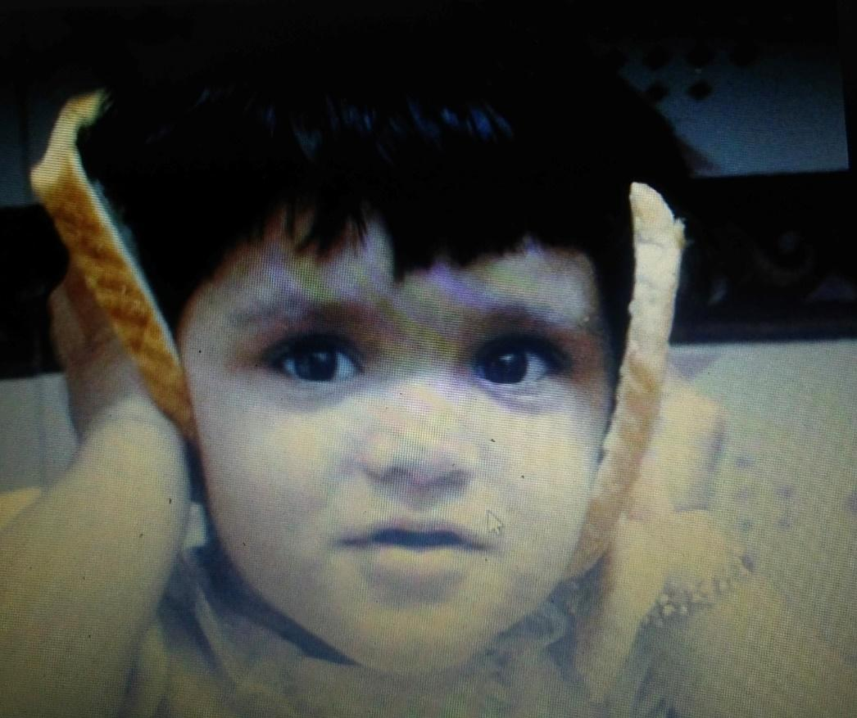

The golden memories are those in which you live, where you reside. Back in 2006, I was sitting on the kitchen slab watching my father talking to someone on a mobile. I found two slices of bread in the kitchen and imitated him.

- KHUSHI JAIN XI D

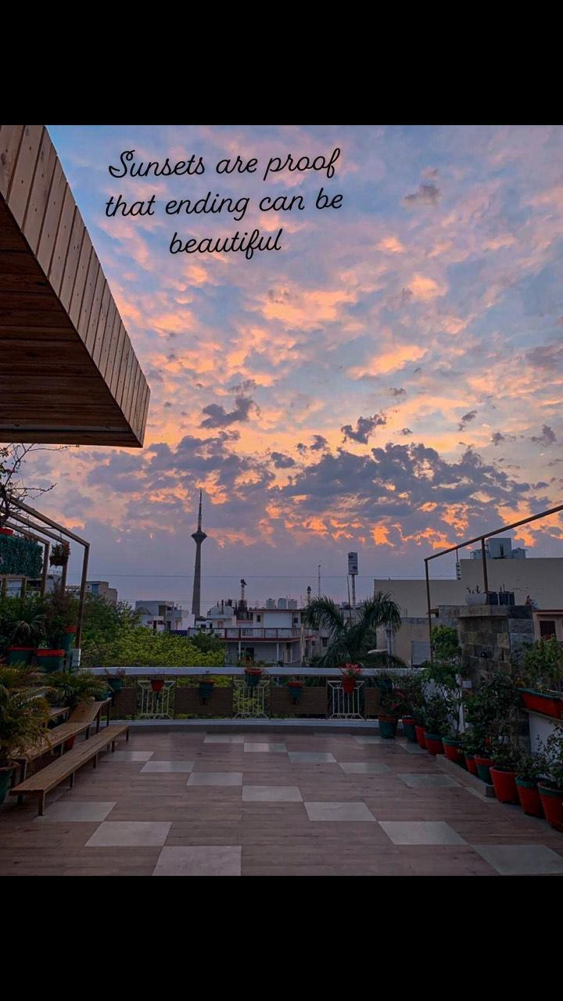

Sunsets are proof that ending can be beautiful.

