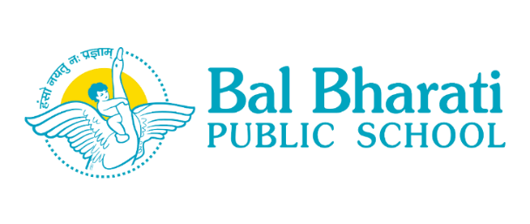

Date: 24.02.2021

PREBOARD EXAMINATION CLASS X & XII 2020-21
Dear Parents,
CBSE has scheduled SSCE and SSE 2021 examination in offline mode in May, 2021 for students of classes X & XII. It is therefore essential for the students to have a hands-on experience of sitting in the examination hall to appear for a three hour paper to boost their confidence while assessing their own preparations for the Board exams. To facilitate the same, the school is conducting offline Preboard examination for classes X and XII in March 2021. The Exams will be conducted in school keeping in mind all safety and security measures required for prevention and spread of Covid -19.
I hope you understand that while for the class XII students the SSCE examination results pave way for their careers ahead, the SSE examination results for class X form the objective criteria for stream allotment at the senior secondary level. The effort of the school in smooth and safe conduct of offline Preboard examination is an endeavor to support our students to achieve academic excellence in the Public Examination.
You are requested to counsel your ward to follow all safety precautions while appearing for the Preboard Examination at school. Kindly ensure that your ward is fully prepared for the examination and does not miss this opportunity of self-evaluation which can facilitate you and your ward in chalking out the remediation strategies for improved final performance. Your intervention and support will be instrumental in bringing out the best in your ward.
All the Best! Stay Safe & Healthy!
Warm Regards

Geeta Gangwani
Principal
BBPS RH

.

