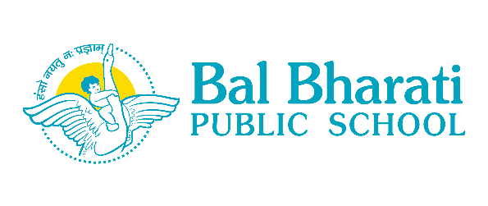

Message for parents
Safe Re-opening of School
27th January, 2021
Dear Parents,
The school is all prepared for the safe re-opening w.e.f 01.02.2021 for Classes X & XII. Kindly visit the school website using the link https://bbpsrohini.balbharati.org/notice-board/ and go through the following documents carefully.
1. Do's and Don'ts for the students.
2. Power Point presentation
- Guidelines for students
- Safe re-opening

Regards,

Geeta Gangwani
Principal

