BAL BHARATI PUBLIC SCHOOL
SECTOR-14, ROHINI, DELHI
CLASS-2 _ ENGLISH _ GRAMMAR
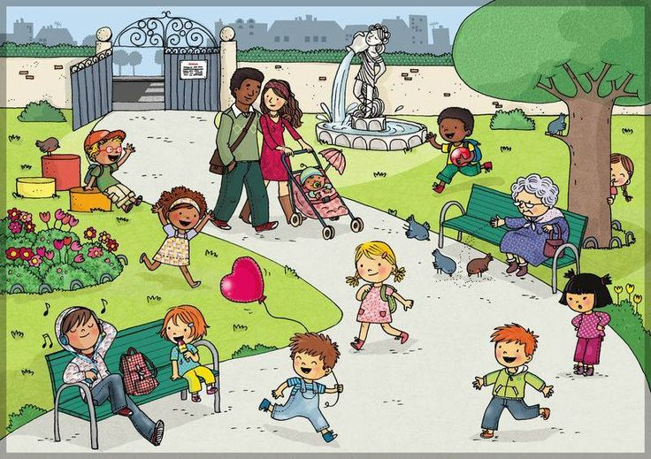
Look at the picture carefully and frame five sentences using the words given below.
PICTURE COMPOSITION
( tree,balloon,fountain,birds,children,flowers,bench)

