BAL BHARATI PUBLIC SCHOOL, ROHINI
CLASS – II
MATHS ASSIGNMENT – 38
* Do this work in your maths notebook.
L – 7 Measurement of length
1. We measure length in metre (m).
2. Shorter lengths are measured in centimetre (cm).
3. Longer lengths / distances are measured in kilometre (km).
4. Tools like scale, inch tape, metre rod are used to measure length.
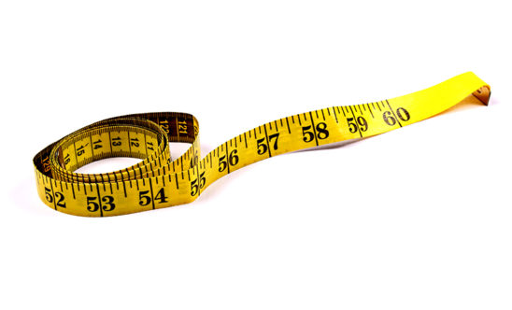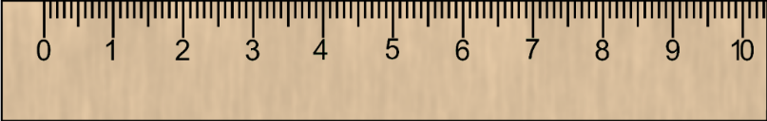

L – 9 Measurement of weight
1. We measure weight in grams and kilograms.
2. Large quantities are measured in kilogram (kg).
3. Small quantities are measured in gram (g).
4. Tools like beam balance, weighing machine are used to measure weight.
