BAL BHARATI PUBLIC SCHOOL
SECTOR-14, ROHINI, DELHI
CLASS-2 _ ENGLISH _ GRAMMAR (ADJECTIVE)

An adjective describes shape, color, size, quality and
quantity (number) of a noun.
Write two suitable adjectives from the box for the pictures given.
tall beautiful thin round yellow heavy
sharp tasty new juicy strong colorful

1.

------------------------
------------------------

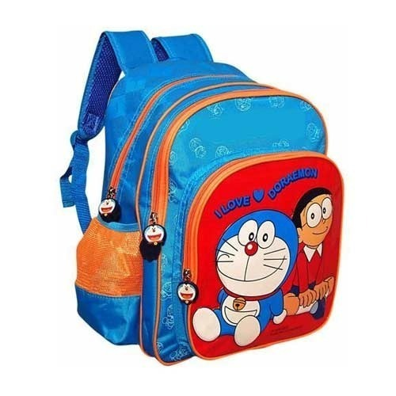
2.
-----------------------
-----------------------

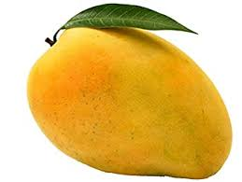
3.
-----------------------
-----------------------

4.
-----------------------
-----------------------

5.
----------------------
---------------------

6.
--------------------
--------------------

