BAL BHARATI PUBLIC SCHOOL
SECTOR-14, ROHINI, DELHI
CLASS-2 _ ENGLISH _ GRAMMAR (PAST TENSE)
Use the past tense of the verbs in the box to fill in the blanks.
go play ring eat give cook paint run buy win
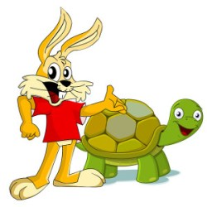
- The tortoise______ the race.

- I _____ banana in the morning.

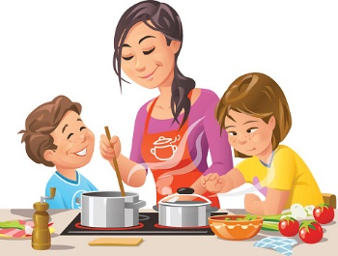

- My mother________ yummy food.

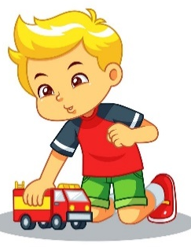

- Amit _______ his toy to play.

- The cat______ after the rat.

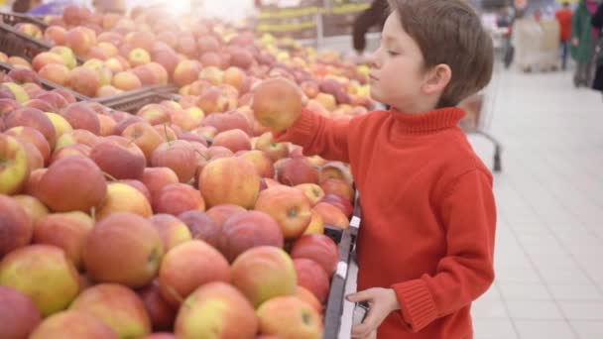
- Karan ______ to the market yesterday.

- The bell________ loudly.

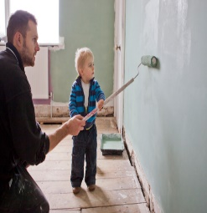

- My father _________ the house.
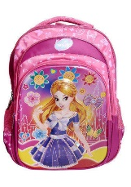

- Tina ________ a new school bag.

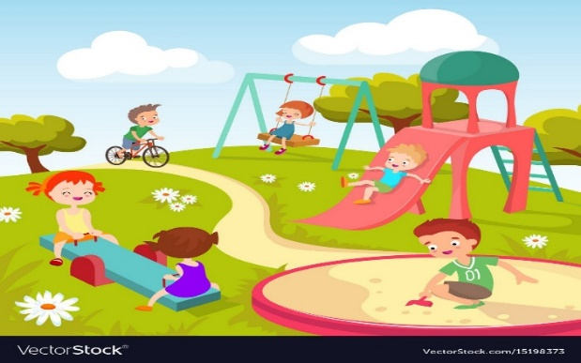

- The children_________ in the park.

