BAL BHARATI PUBLIC SCHOOL
SECTOR-14, ROHINI, DELHI
CLASS-2 _ ENGLISH _ PRONOUNS

A pronoun is a word that can take place of a noun.

Q. Circle the pronouns in the given sentences.
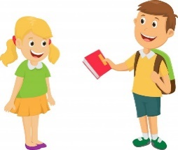
1. Bunty gave me a book.

2. Tina met her cousin last week.

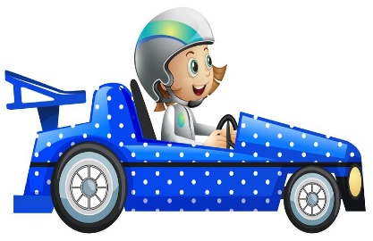
3. She is sitting in the car.

4. Father gave us ice cream.

5. It is a pretty dress.

6. They are enjoying having pizza.

7. He won the dancing competition.

8. My mother gave him a bag.

9. We are enjoying the movie.

10. His sister is my best friend.

