BAL BHARATI PUBLIC SCHOOL
SECTOR-14,ROHINI,DELHI
CLASS-I_ENGLISH_(This-That)

*Look at the pictures and fill in the blanks with ‘this’ or ‘that’.
- _______ is a pen.
- _______ is a kite. 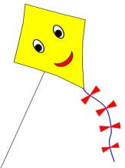
- _______ is a tree. 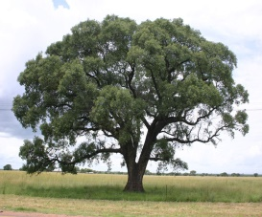
- 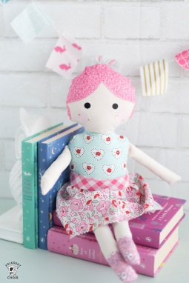 _______ is my doll.
- 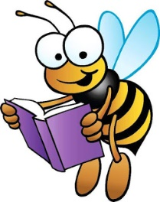 _______ is a story book. 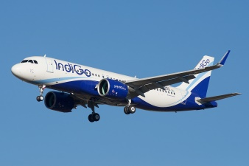

- ________ is an aeroplane . Prepared By-Hemlata,BBPSRH

