BAL BHARATI PUBLIC SCHOOL
SECTOR-14,ROHINI,DELHI
CLASS-1 _ENGLISH_PICTURE READING
**Look at picture and fill in the blanks.(clues are given in the bracket)
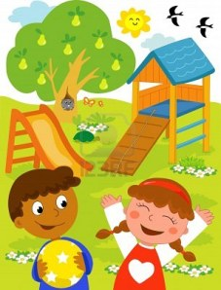
- This is a ____.(place)
- The boy has a ____.(thing)
- The ____ is happy.(person)
- There is a big ____ tree.(fruit)
- ___ birds are flying in the sky.(number)
- The boy is wearing a ____ shirt.(colour)
- There are many _____ flowers all over.(colour)
- There is a ____ nest on the tree.(animal)

Prepared by-Ms.Hemlata
BBPSRH.

