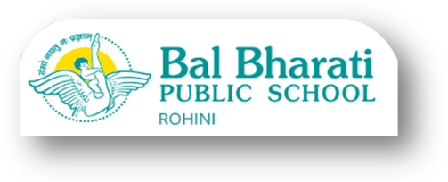

Date: 07.01.2021
Dear Parents (X, XII)
You are hereby informed that the report cards of the Online Periodical Exam held in the month of December, 2020 have been generated and mailed on the Gsuite id of your ward. Please make a note of the progress of your ward in these exams.

Regards

Geeta Gangwani
(Principal)

