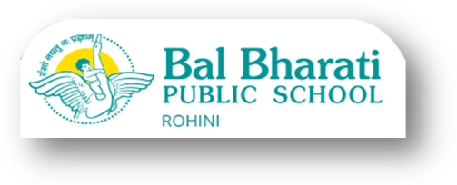

Date: 6th January,2021
Online Assessment for Classes VI-VIII

Dear Parents
Wishing you all a happy and a prosperous New Year.
We are planning to hold the second set of Online Periodical Assessment of the students after the winter break. The details of the syllabus to be included will be provided by the subject teachers. The assessment will be done via Google form.
The Question Paper will be of 25 marks for 1 hour. The format of the Question paper will be as given below:
1. MCQs with one option as correct answer
2. MCQs with more than one option as correct answers

Kindly note, it is mandatory for the students to appear for this assessment as it will be recorded for the overall assessment of the student over the year.

ALL THE BEST!!
Geeta Gangwani
Principal
BBPS RH

Bal Bharati Public School Rohini
Online Assessment Schedule January, 2021
Session: 2020-21
Class VI, VII and VIII
DATE | DAY | VI | VII | VIII
18/01/21 | MON | SOCIAL SCIENCE | SCIENCE | MATHS
22/01/21 | FRI | HINDI | SANS/FRENCH/GERMAN | ENGLISH
25/01/21 | MON | MATHS | SOCIAL SCIENCE | SCIENCE
29/01/21 | FRI | ENGLISH | HINDI | SANS/FRENCH/GERMAN
01/02/21 | MON | SANS/FRENCH/GERMAN | ENGLISH | SOCIAL SCIENCE
05/02/21 | FRI | SCIENCE | MATHS | HINDI

NOTE:
- The timings for the Online assessment will be from 10 am to 11 am.
- The classes will remain suspended on the day of the online assessment.

