BAL BHARATI PUBLIC SCHOOL
SECTOR-14,ROHINI,DELHI
CREATIVE CRITICAL THINKING WORKSHEET-4
MATHS, CLASS-1 (ANSWER KEY)

MY FAVOURITE SHAPE !
Each child has his own favourite shape.
Use the clues given below to find out their favourite SHAPE.
CLUES:* Ria’s favourite shape is round .
* Somu’s favourite shape has 4 equal sides.
*Tina’s favourite shape has 4 sides but they aren’t equal.
*Monu likes a three sided shape.
{TINA MONU RIA SOMU } ##Join the dots to form the shapes , name and colour them matching to their clothes.

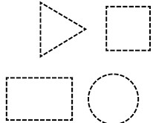
Riya likes-
Somu likes -
Tina likes -
Monu likes-
Prepared by:Ms. Hemlata
BBPSRH.

