BAL BHARATI PUBLIC SCHOOL
SECTOR-14,ROHINI,DELHI
CLASS-1_MATHS_SHAPES
COLOUR THE SHAPE CHALLENGE!
**Use the clues to colour the shapes.
#COLOUR
- the smallest square red .
CIRCLE THE
BIGGEST NUMBER RED
SMALLEST NUMBER BLUE
10, 9, 2, 4, 6
- the biggest square brown.
- the smallest rectangle purple.
- the biggest rectangle green.
- the smallest circle yellow.
- the biggest circle blue.
- the smallest triangle orange.
- The biggest triangle black
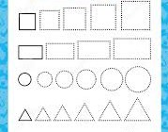
Prepared By-Ms.Hemlata
BBPSRH

