BAL BHARATI PUBLIC SCHOOL
SECTOR-14,ROHINI,DELHI
MATHEMATICS
CLASS-1_MATHS_ SHAPES
- Count the different shapes in each figure and write the number in the corresponding shapes drawn in front of each picture.
a)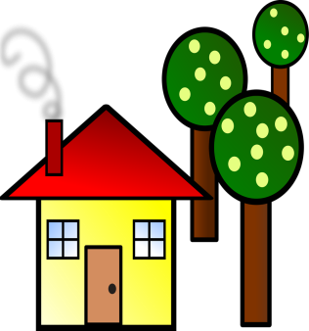
___
_____
_____
_____

b)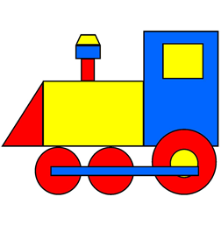
___
___
___
____
`
c)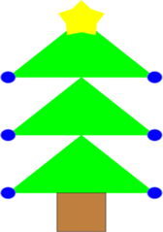
___
____
___
___

Prepared by –Ms. Hemlata
BBPSRH

