BAL BHARATI PUBLIC SCHOOL
SECTOR-14,ROHINI,DELHI
CLASS -1_ MATHS _NUMBER NAMES
- Count and draw arrow to the correct number.
a)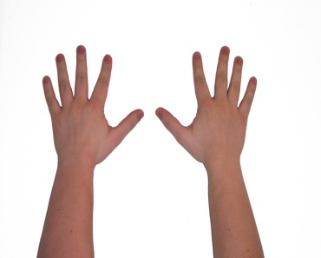 * fifteen
b) * ten
c)
*twelve
d) 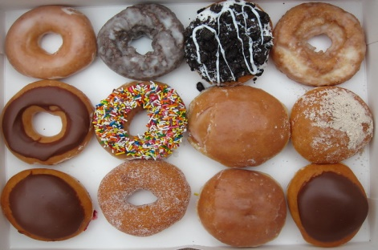 *fourteen

e) *thirteen
2) Draw as many cherries in the basket as shown in the cloud near by.
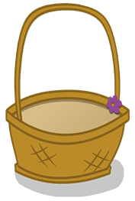
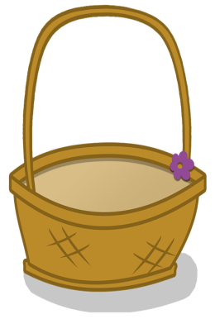
eight
eleven

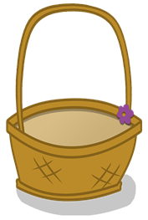
four
nine
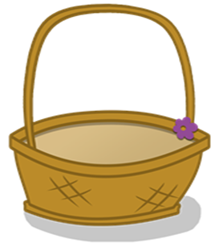
Seven
five

PREPARED BY:
MS.HEMLATA
BBPSRH

