BAL BHARATI PUBLIC SCHOOL Sec. 14, ROHINI

Creative Critical Thinking Worksheet-9

MATHS
CLASS III
ANSWER KEY

PREPARED BY- MANISHA MATHUR
BAL BHARATI PUBLIC SCHOOL,ROHINI
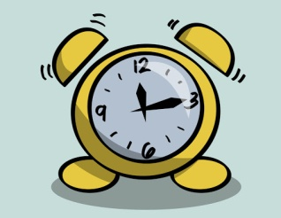 TIME IS TICKING…..TICK TOCK
SARA WORKS IN HER GARDEN FOR TWO AND HALF HOURS DAILY.IF SHE STARTS HER WORK AT 10:30 A.M .AT WHAT TIME WILL SHE GET FREE? 1:00 PM
BULBUL CAME BACK HOME AT 7:00 PM FROM HER 3 HOUR LONG DANCE CLASS . AT WHAT TIME DID HER DANCE CLASS STARTS? 4:00 PM
4:00 PM
GUNGUN WENT TO HER NANIS HOUSE ON 14TH JANUARY. SHE CAME BACK AFTER TWO WEEKS. ON WHICH DATE DID SHE RETURN? 28TH JANUARY.
RUMA IS COMING BACK FROM MUMBAI TO DELHI BY EXPRESS TRAIN. IT STARTED FROM MUMBAI ON WEDNESDAY AT 3;00PM AND WILL 15 HOURS TO REACH DELHI. WHEN WILL RUMA REACH DELHI? GIVE THE TIME AND DAY. 6:00AM

