BAL BHARATI PUBLIC SCHOOL
SECTOR-14,ROHINI DELHI
CLASS-1 _ ENGLISH_ OPPOSITES
** Find out the antonym (opposite) of the words from the picture clues below.
- Cold - ________________
- Clean - ________________
- Wet - ________________
- Big - ________________
- Sad - ________________
- Young - ________________
- Slow - ________________
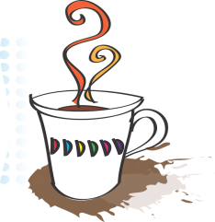
# PICTURE CLUES___

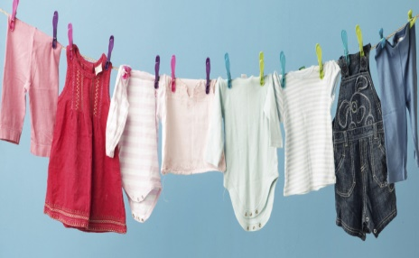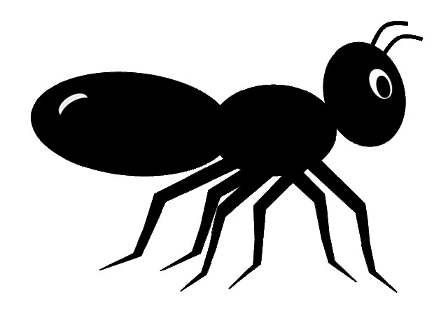
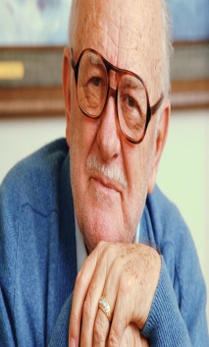 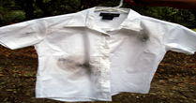 PREPARED BY-Ms.Hemlata
BBPSRH

