BAL BHARATI PUBLIC SCHOOL,
SECTOR-14,ROHINI,DELHI
CLASS-1 _ ENGLISH _ READING COMPREHENSION
## Complete the story by filling in a letter in the blank .The picture clues will help you.
The __ __ __ was shining . The __ __ __ was sleeping.The
__ __ __ was also sleeping. The __ __ __ was feeding the chicks.
A cunning __ __ __ came near. The __ __ __ cried HELP! HELP! The other animals hid in the __ __ __.The __ __ __ flew into the 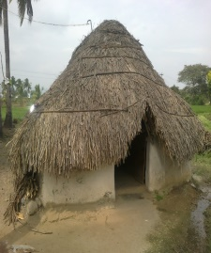 __ __ __. A__ __ __ came for help. The __ __ __ jumped into the 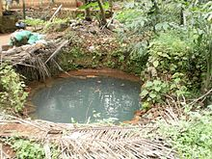 __ __ __ __. The __ __ __ kept smiling the whole day.

Prepared by –Ms. Hemlata
BBPSRH.

