BAL BHARATI PUBLIC SCHOOL
SECTOR-14,ROHINI,DELHI
CLASS-1 _ ENGLISH _ IDENTIFY SOUNDS
- Match the picture with the correct word.
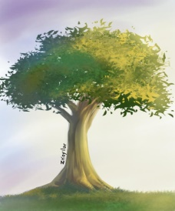
free
1) tree
bee

2) cool
pool
wool
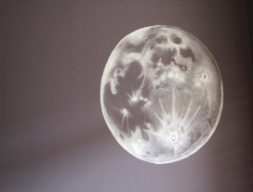
room
3) moon
zoom

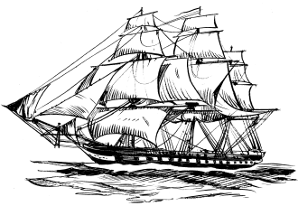
boat
4) coat
bloat

5) book
hook
cook

- Circle the words that begin with the same sound written in smiley .
Sh

snake shake shape

Ph
Ch

church crow chips

pond phone photo

Th

this tale that

Prepared by- Ms.Hemlata,
BBPSRH.

