BAL BHARATI PUBLIC SCHOOL, ROHINI
CREATIVE CRITICAL THINKING WORKSHEET- 9
CLASS –III SUBJECT- ENGLISH

Q1. Use the picture clues to solve the crossword puzzle.

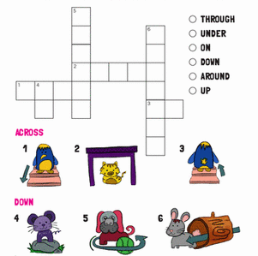
Q2. Look at the pictures and tick the sentence with correct preposition.

- Jam is in the bottle.
- Jam is on the bottle.
- Jam is under the table.

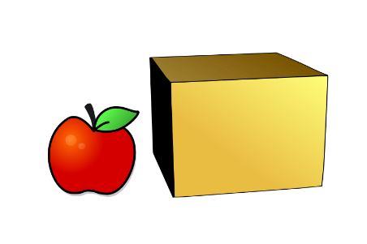
- The apple is on the box.
- The box is in the apple.
- The apple is beside the box.

3)
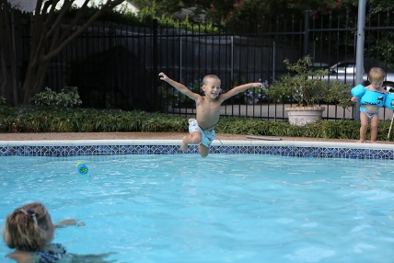

- The boy jumped in the pool.
- The boy jumped into the pool.
- The boy jumped under the pool.

Prepared by:
Ms. Deepali Sharma
Bal Bharati Public School, Rohini

