BAL BHARATI PUBLIC SCHOOL, ROHINI
CREATIVE CRITICAL THINKING WORKSHEET-8
CLASS –III SUBJECT- ENGLISH
Q1. Look at the pictures and write the verbs.
1. s __ __ __

2. s __ __ __

3. c __ __

4. w __ __ __ __

Q2. Choose the correct verb and complete the sentence.
- Amit ____________ many pets. (is / has)
- They _________ good friends. (am / are)
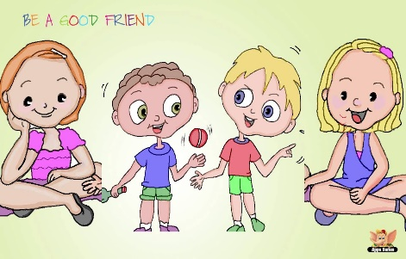
- Anu _________ in Mumbai. (lives / have)
- I _____ an obedient student. (is / am)

Prepared by:
Ms. Deepali Sharma
Bal Bharati Public School, Rohini

