BAL BHARATI PUBLIC SCHOOL, SECTOR-14, ROHINI
CREATIVE CRITICAL THINKING WORKSHEET-7
CLASS- III SUBJECT- ENGLISH
Note : Do the worksheet in English notebook. Write the answers only.
Q1. Colour the words in the grid to make sentences for the given pictures.

A | an | she | he
table | apple | rainbow | pencil
had | has | have | seven
boxes | colours | pieces | pens

SENTENCE :

An | elephant | are | on
is | was | were | it
on | a | huge | I
plant | animal | insect | thing

SENTENCE :

Q2. Look at the pictures and choose from the given predicates to complete each sentence.
- The boy _____________________.
- is running.
- is playing football

- The phone _______________________
- is ringing
- is kept on the book
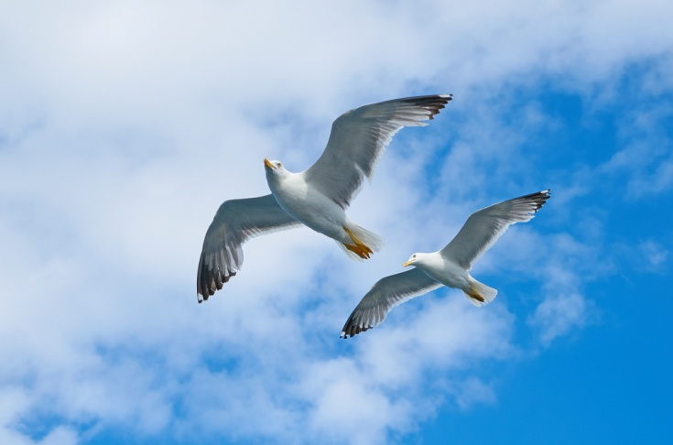
- The birds__________________
- are beautiful
- are flying in the sky.

Prepared by:
Ms. Deepali Sharma
Bal Bharati Public School, Rohini

