BAL BHARATI PUBLIC SCHOOL, SECTOR-14, ROHINI
CREATIVE CRITICAL THINKING WORKSHEET-6
CLASS- III SUBJECT- ENGLISH

Q1) Solve the crossword puzzle using the clues given.

CLUES DOWN CLUES ACROSS
1)The ______ flies an aeroplane. 1)A traveller
4)A doctor treats ______ people. 2)A key opens a _______.
5)The opposite of day is ______ 3) The opposite of bad is ____.
6) Rohit loves to ______ a bike.

1) P | A | 4) S | S | E | 5)N | G | E | 6)R
2) L |  |  |  |  | 3)G

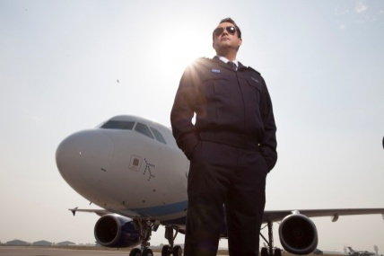

Q2) Write a word of five letters which has a similar meaning to the word underlined. The first letter of each word is given.

- Everyone praised Nikhil for his courageous act. b _ _ _ _

- The Prime Minister gave a short speech. b _ _ _ _

- The flower beds in our garden are circular in shape. r _ _ _ _
- Nobody can compel you to go out. f _ _ _ _

- He attempted to lift the heavy bag. t _ _ _ _
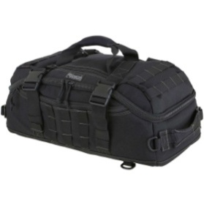
Prepared by-
Ms. Deepali Sharma
Bal Bharati Public School, Rohini

