BAL BHARATI PUBLIC SCHOOL, SECTOR -14, ROHINI
CREATIVE CRITICAL THINKING WORKSHEET-5
SUBJECT- ENGLISH CLASS: III
Q1.Read, understand and do. Follow each step to change one word into another word.
BRAIN
Remove the first letter
- R ___ ___ ___
Replace R with an M
- ___ ___ ___ ___
Replace N with a D
3) ___ ___ ___ ___ Remove the letter A
4) ____ ____ ____
Add N after the letter I
5) ___ ___ ___ ___
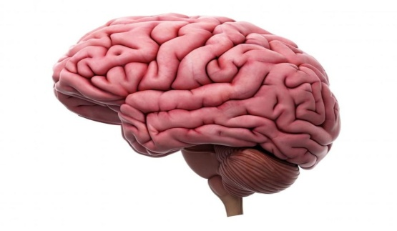
Q2. Fill in the blanks with words from the box. Look for the clues given in the bracket.
- Vicky wakes up at ___________. (when the sun is just rising)
- He has his lunch at ___________. (in the middle of the day )
- He goes for a walk at____________.(when the sun is setting)
- The barking of the dogs wakes him up at _____________. (middle of the night)

midnight sunrise midday sunset

Q3. Circle the synonyms of the words written in capital letters.

- PLUMP - thin small fat tall

- ASSEMBLE - clear collect fold create

- ENORMOUS- cold big tiny hot

- QUARREL - fight hate love find

Prepared by:
Ms. Deepali Sharma
Bal Bharati Public School, Rohini

