BAL BHARATI PUBLIC SCHOOL, SECTOR -14, ROHINI
CREATIVE CRITICAL THINKING WORKSHEET-4
SUBJECT- ENGLISH CLASS: III

Q1. Add same two letters to make new words. Meanings are given to help you.

 |  | F | E | N | C | E

 |  | L | I | G | H | T

2)

 |  | S | E | R | V | E
3)

 |  | L | I | V | E | R
4)

Meanings-
- protecting someone
- great happiness
- to be worthy of
- to hand something over

Q2. Rearrange the letters to make eight words. Then write four pairs of synonyms in the given boxes.
- NEKE - _________ 5) WORROS - __________
- TTUTS-_________ 6) RAGEE - ___________
- FWIST-_________ 7) LEBEEIV- ____________
- FIERG-__________ 8) QIKUC - ____________

_____________ _______________
_____________ _______________

______________ ________________
______________ ________________

Q3. Understand the relationships suggested in each of these sentences and supply the missing words.

- LOW is to HIGH as ___________ is to HUGE.

- EUROPE is to __________ as JAPAN is to COUNTRY.

- FLOWER is to _________ as PLAYER is to TEAM.

- _________ is to MICE as LEAF is to LEAVES.

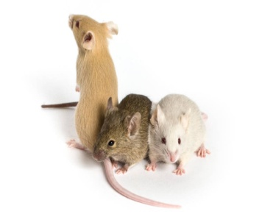

Prepared by:
Ms. Deepali Sharma
Bal Bharati Public School, Rohini

