BAL BHARATI PUBLIC SCHOOL, ROHINI
CRITICAL THINKING WORKSHEET - 2
Subject: English Class –III

Q 1. For each animal circle the adjective that best describes it.

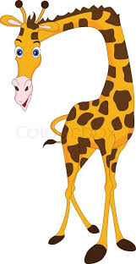
small big tall
huge fast tiny
thin slow fat

Q 2. Match the adjectives in column A with nouns in column B. Complete the blanks with pairs of words from the two columns.

A B
beautiful book
cold tail
long coffee
interesting butterfly

- There is a ____________________________ in the garden.
- My father likes to drink ________________________ .
- The monkeys have ____________________________.
- Ruchi is reading an_____________________________.
Q3. Compare the people or things and make a sentence on each picture.
_____________________________________

____________________________________

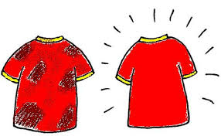 __________________________________
Q 4. Circle the odd adjective in each set.
- fat plump slim chubby

- tall tiny lofty high

- thin heavy slim slender

- cold chilly frosty warm

- big small large huge

Prepared by:
Ms. Deepali Sharma
PRT, Bal Bharati Public School, Rohini

