BAL BHARATI PUBLIC SCHOOL
Sec-14, Rohini, Delhi
CREATIVE CRITICAL THINKING WORKSHEET-1
ENGLISH
Class – III
Read the posters and answer the questions that follow.
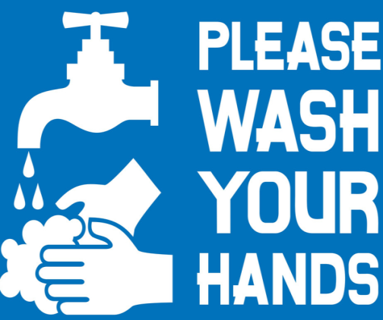
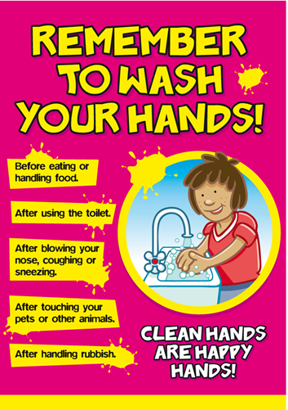
Q1. What should be used to wash hands thoroughly?
_____________________________________________________
Q2. Why should you clean your hands often?
_____________________________________________________

Q3. Choose the correct answer-
- You can also use ____________ to clean your hands if soap and water is not available.
- alcohol b) sanitizer c) sand
- Antonym of happy is-
- ugly b) bad c) sad
Q4. Write any three verbs used in the posters.
- __________ b) __________ c) __________
Q5. Followig are the safety tips that you should follow to help prevent the spread of COVID-19. Complete the sentences using the verbs given in the help box.
wear cover disinfect wash
- __________ your hands for at least 20 seconds.
- Avoid touching your nose, eyes and mouth.
- __________ your mouth and nose while sneezing and coughing.
- Practice social distancing.
- __________ frequently touched surfaces.
- __________ a mask if you need to go out.

Prepared by:-
Ms. Deepali Sharma
PRT, Bal Bharati Public School, Rohini

