BAL BHARATI PUBLIC SCHOOL,ROHINI
CLASS –III SUBJECT- ENGLISH
ASSIGNMENT NO.-41
TOPIC – READING COMPREHENSION
Read the passages carefully and answer the questions that follow. (Note: Write only the answers in English Notebook)
1...
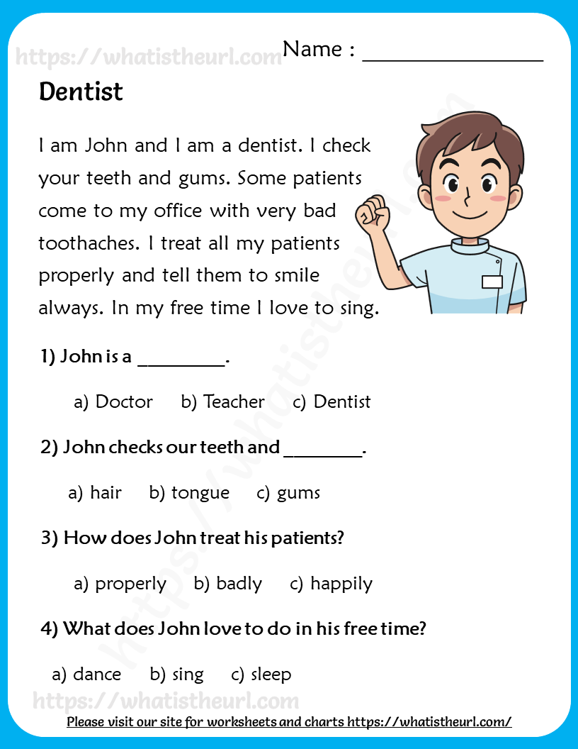

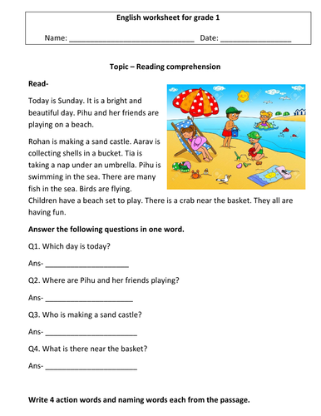
2.

