BAL BHARATI PUBLIC SCHOOL,ROHINI
CLASS –III SUBJECT- ENGLISH
ASSIGNMENT NO.-41
TOPIC – READING COMPREHENSION
Read the passages carefully and answer the questions that follow. (Note: Write only the answers in English Notebook)
1...
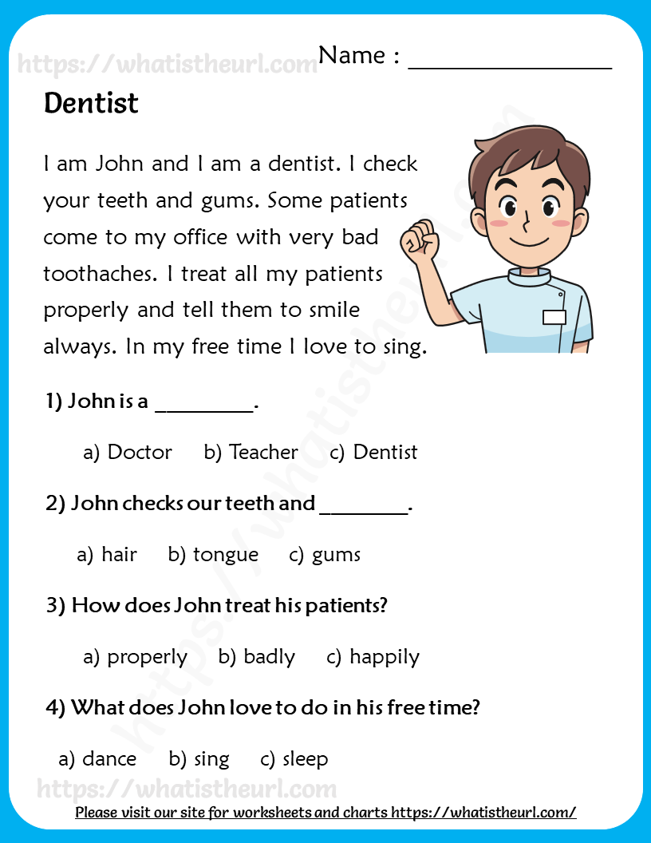

Answers
- Dentist
- gums
- properly
- sing
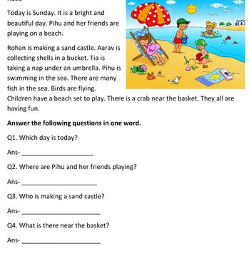
2.
Answers
- Today is Sunday.
- Pihu and her friends are playing on a beach.
- Rohan is making a sand castle.
- There is a crab near the basket.

