BAL BHARATI PUBLIC SCHOOL, ROHINI
CLASS –III SUBJECT- ENGLISH
ASSIGNMENT NO.-39
TOPIC – CONJUNCTIONS
Words that join two words or sentences are called Conjunctions or Joining Words.
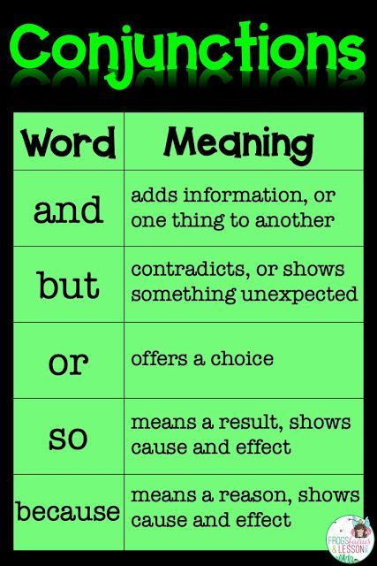

Ex 1. Circle the Conjunctions.
- Anita and Sunita are good friends.
- He is crying because he got hurt.
- Do you want tea or coffee?
- Varun is intelligent but lazy.

Ex 2. Fill in the blanks with suitable conjunctions.
- Arjun went to the market and bought vegetables.
- We must wash our hand frequently because it kills the germs.
- You can buy red or blue shirt.
- Tarun played well but could not score a goal.

