BAL BHARATI PUBLIC SCHOOL, ROHINI
CLASS –III SUBJECT- ENGLISH
ASSIGNMENT NO.- 33
TOPIC – MOTHER WOLF SAVES MOWGLI

Answer this question with reference to the context. (RTC)

2. The man’s baby is mine.

- Who said these words and to whom?
Ans. Mother Wolf said these words to Shere Khan.

- Why did the speaker say these words?
Ans. Mother wolf said these words to protect the man’s baby from Shere Khan, who wanted to hunt the baby.

c. How did the listener react?
Ans. Knowing that he did not stand a chance against Mother Wolf, Shere Khan growled, backed out and went out of the cave.

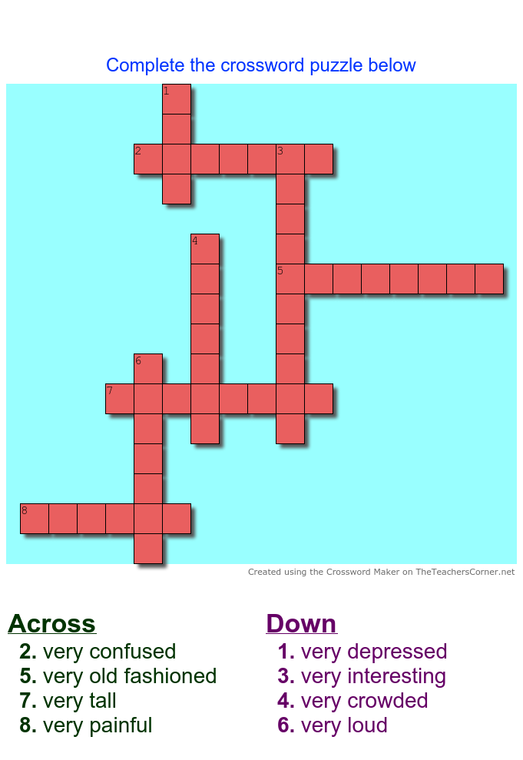
ACTIVITY- VOCABULARY ENRICHMENT
Complete the crossword using the clues given.
CLUES
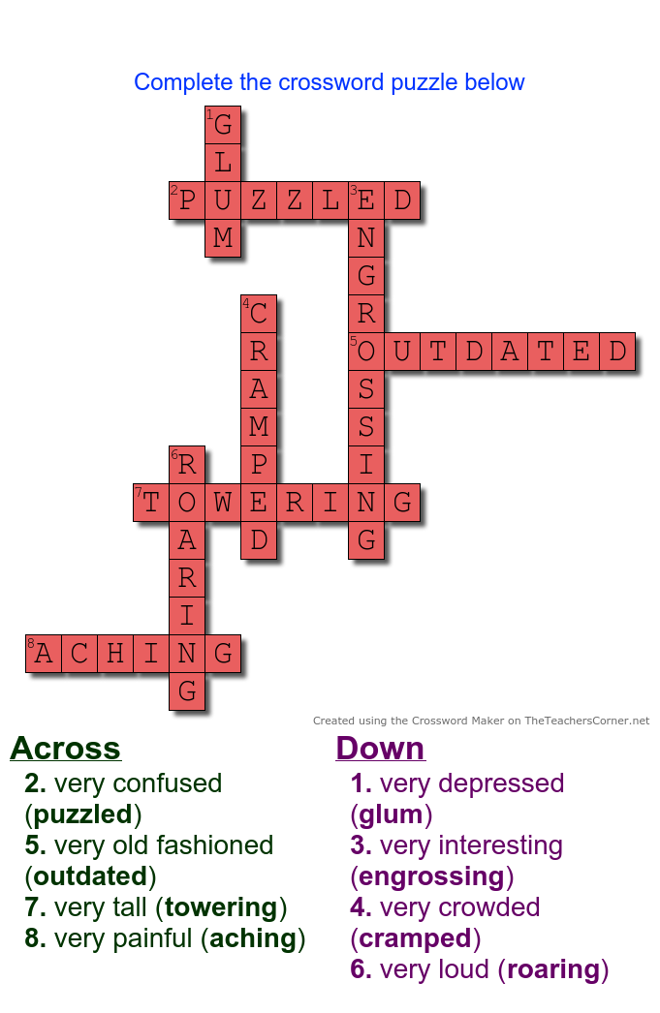
ANSWER KEY

