BAL BHARATI PUBLIC SCHOOL, ROHINI
CLASS –III SUBJECT- ENGLISH
ASSIGNMENT NO.-30
TOPIC – PICTURE COMPOSITION
- Complete the compositions with the help of words given in the help box.
3

red, market, meat, fruits, vegetables, dog

The picture depicts a (1) market scene. The vendors are selling fresh (2) fruits and (3) vegetables . The meat seller is selling (4) meat. A man and a woman are walking on the road with their (5) dog. A woman wearing yellow dress is carrying a (6) red bag for shopping.
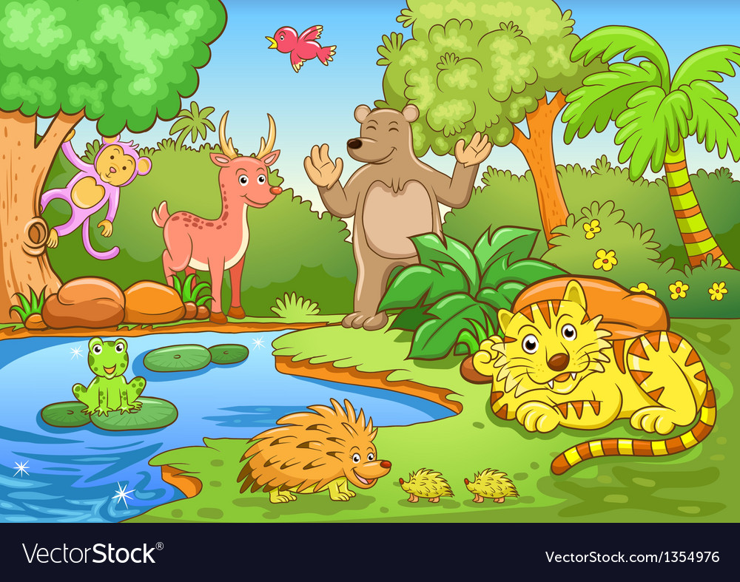
4

bird, frog, forest, pond, animals, monkey

The picture depicts a (1) forest scene. There are many (2) animals in the forest. A (3) monkey is swinging on the branch of a tree. There is a (4) pond and many trees in the forest. There is a (5) frog in the pond. A beautiful (6) bird is flying in the sky.

