BAL BHARATI PUBLIC SCHOOL, ROHINI
CLASS –III SUBJECT- ENGLISH
ASSIGNMENT NO.-29
TOPIC – PICTURE COMPOSITION

- Complete the compositions with the help of words given in the help box.
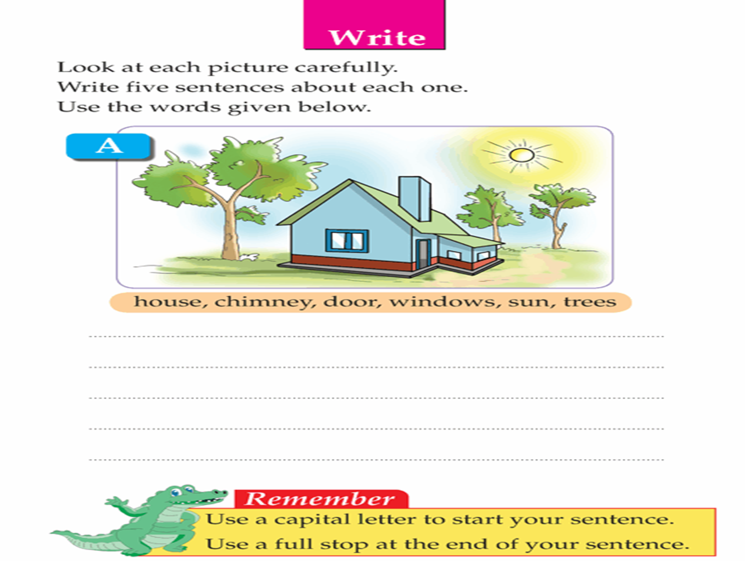
1

The picture depicts a (1) house surrounded by huge (2) trees. The (3) sun is shining brightly. There is a (4) chimney on the roof of the house. There is one (5) door and few (6) windows in the house.

2

frog , rainy, umbrella, rainbow, raincoat, flowers

The picture depicts a (1) rainy day. A girl is wearing a (2) raincoat. She is holding a pink (3) umbrella. A (4) rainbow is visible in the sky. Beautiful (5) flowers are blooming. A snail and a (6) frog are also enjoying in the rain.

