BAL BHARATI PUBLIC SCHOOL, ROHINI
CLASS –III SUBJECT- ENGLISH
ASSIGNMENT NO.-23
TOPIC – VERBS

Verbs are of three types.

1)Action Verbs- show action e.g. sit, stand, walk etc

2)Being Verbs- show state of being e.g. is, am, are, was ,were etc

3)Possessing Verbs- show ownership or possession e.g. has, have, had
Ex 1. Look at the pictures and write the action verbs. 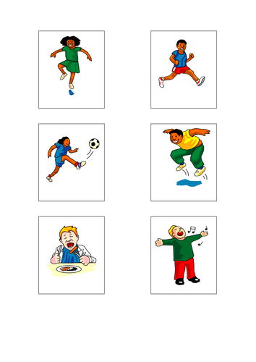
1) dance
2) kick
3) eat
4) run
5) jump
6) sing
Ex 2. Fill in the blanks with suitable action verbs given in the box.
- We write neatly.
- Farmers grow crops.
- Children play in the park.
- The trees give us shade.

give play grow write

Ex 3. Unscramble and write the action words.
- d y s u t – study

- r i n g b – bring

- n k d r i – drink

- t a s d n - stand

