BAL BHARATI PUBLIC SCHOOL, ROHINI
CLASS- III SUBJECT- ENGLISH
ASSIGNMENT -13
TOPIC : COVID -19 WORD SEARCH
NOTE –Write only the words in English notebook.

Find and write the words associated with COVID-19 and its management in the given WORD SEARCH.

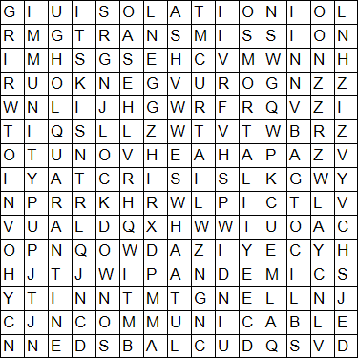

CLUES-
- crisis- a time of great danger and difficulty
- pandemic- a disease that spreads over whole world
- isolation- the state of being separate and alone.
- communicable- the disease that can spread from one person to another
- mortality- number of deaths in one period of time
- quarantine- a period of time when a person that may have an infectious disease is kept away from other people.
- immunity- the ability to avoid or not be affected by a disease
- lockdown-an emergency measurein which people are prevented from entering orleaving an area
- transmission- process by which a disease is spread from one person to another
- curtail- to reduce or limit something

