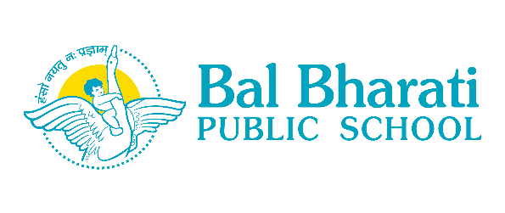

***“Take the first step in faith. You don’t have to see the whole staircase, just take the first step.” Martin Luther King Jr***

4th February, 2021

**Dear Parents,**

2020 has been a challenging year for all of us. The students have remained away from the school building for more than ten months due to the COVID 19 pandemic in the country. However, 2021 brings us the hope of normalcy with arrival of vaccines and government’s decision to reopen school in a phased manner. As per the guidelines from DOE, the school has already started with offline classes for X & XII and is ready to welcome the students of Classes IX & XI. Kindly note the following information regarding the reopening process for Classes IX & XI.

1. The syllabus for Final Examination for Classes IX & XI is expected to be completed by 15th February, 2021 through online classes
2. The Remediation Classes for IX & XI will begin from 17th February, 2021 offline mode in the school premises. A separate circular with details will be sent soon.
3. The final examination for Classes IX & XI will begin from 1st week of March, 2021 and will be conducted offline mode in the school premises.

You are requested to note the aforesaid schedule. However, the same is subject to change in case new guidelines are issued by DOE.

Soliciting your benign support and cooperation.

Regards,

Geeta Gangwani

Principal