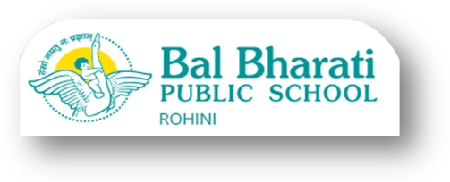

15.01.2021

Dear Parents,
COVID-19 Pandemic situation has been unprecedented for the teachers, students and parents. To combat COVID-19 situation and keeping the health of the students on top priority, all the schools running under Directorate of Education, Govt. of NCT of Delhi have been closed since 19th March 2020.
As per the Directorate of Education Circular No.DE.5/43/04/Exam/2019-20/39-46 dated 13 January2021, the school wants to apprise you of the latest developments in the procedure designed for the re-opening of the schools.
1. As per the CBSE Notification issued by Controller of Examinations, Central Board of Secondary Education, Delhi, the Board Examinations for classes X and XII will commence from 4thMay, 2021.
2. In order to conduct activities pertaining to pre--board examinations, internal assessments, project completion and practical work, the Head of Government, Govt. aided and unaided recognized schools can call the students of Classes 10 and 12 to school with effect from 18th January 2021.
3. Schools affiliated to CBSE will be allowed to conduct Practical/Project/Internal Assessment of classes X & XII from 1stMarch, 2021 to the last date of conduct of theory examination of the same class.
It is in this regard that the school seeks your consent for sending your ward to school from 1st February 2021 for resuming physical classes. Detailed plan for re-opening, time table and Standard Operating Procedure (SOP prepared by the school) will be shared after a decision is taken for the same, based on parents' response. Kindly find the link below for your consent.
Regards
GEETA GANGWANI
Principal

https://docs.google.com/forms/d/e/1FAIpQLSfAJMImKaymtVQ38JPeLMf9TwM-TQ_BT9P-2gI6a9K5hnnuIw/viewform?usp=sf_link

